实验十二 SpringMVC

一、实验目的
- 掌握SpringMVC项目构建
- 掌握SpringMVC数据接收与传递的原理

实验过程
- 配置SpringMVC开发环境
  - 创建新的项目，TestSpringMvc
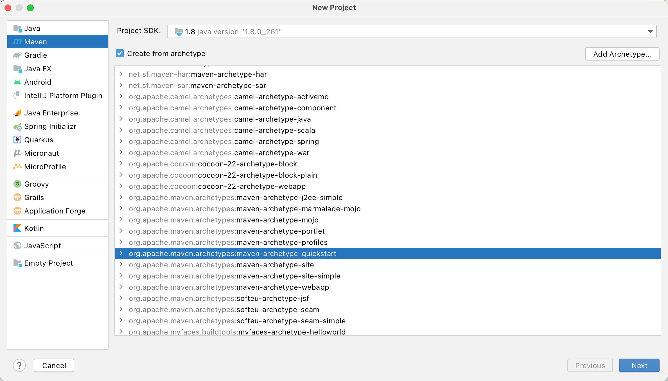
  - 为项目添加Web框架和SpringMVC框架
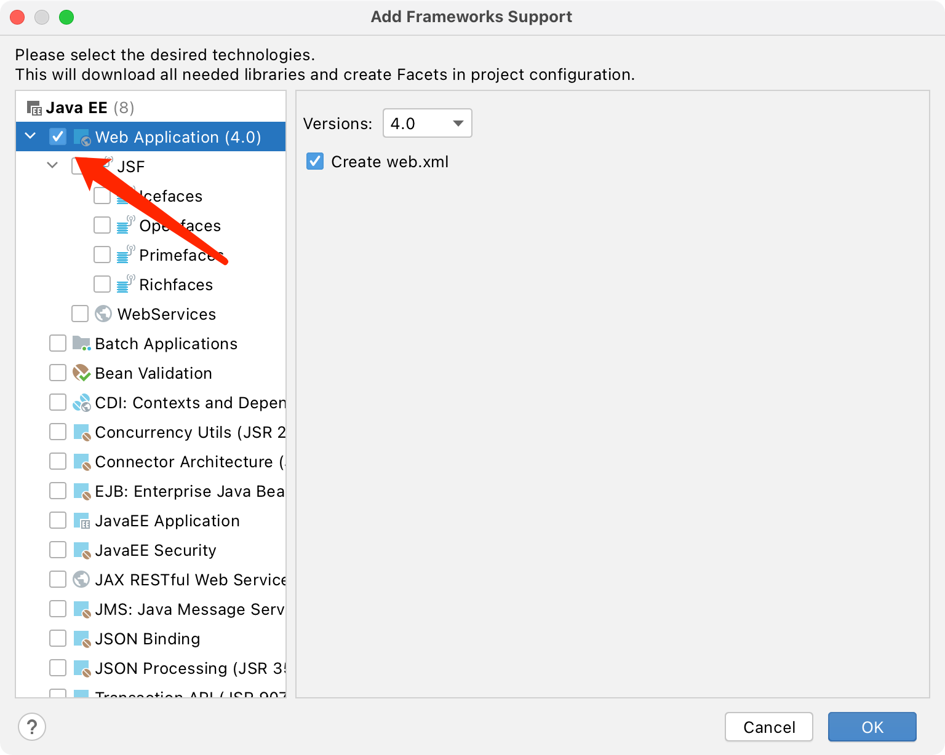
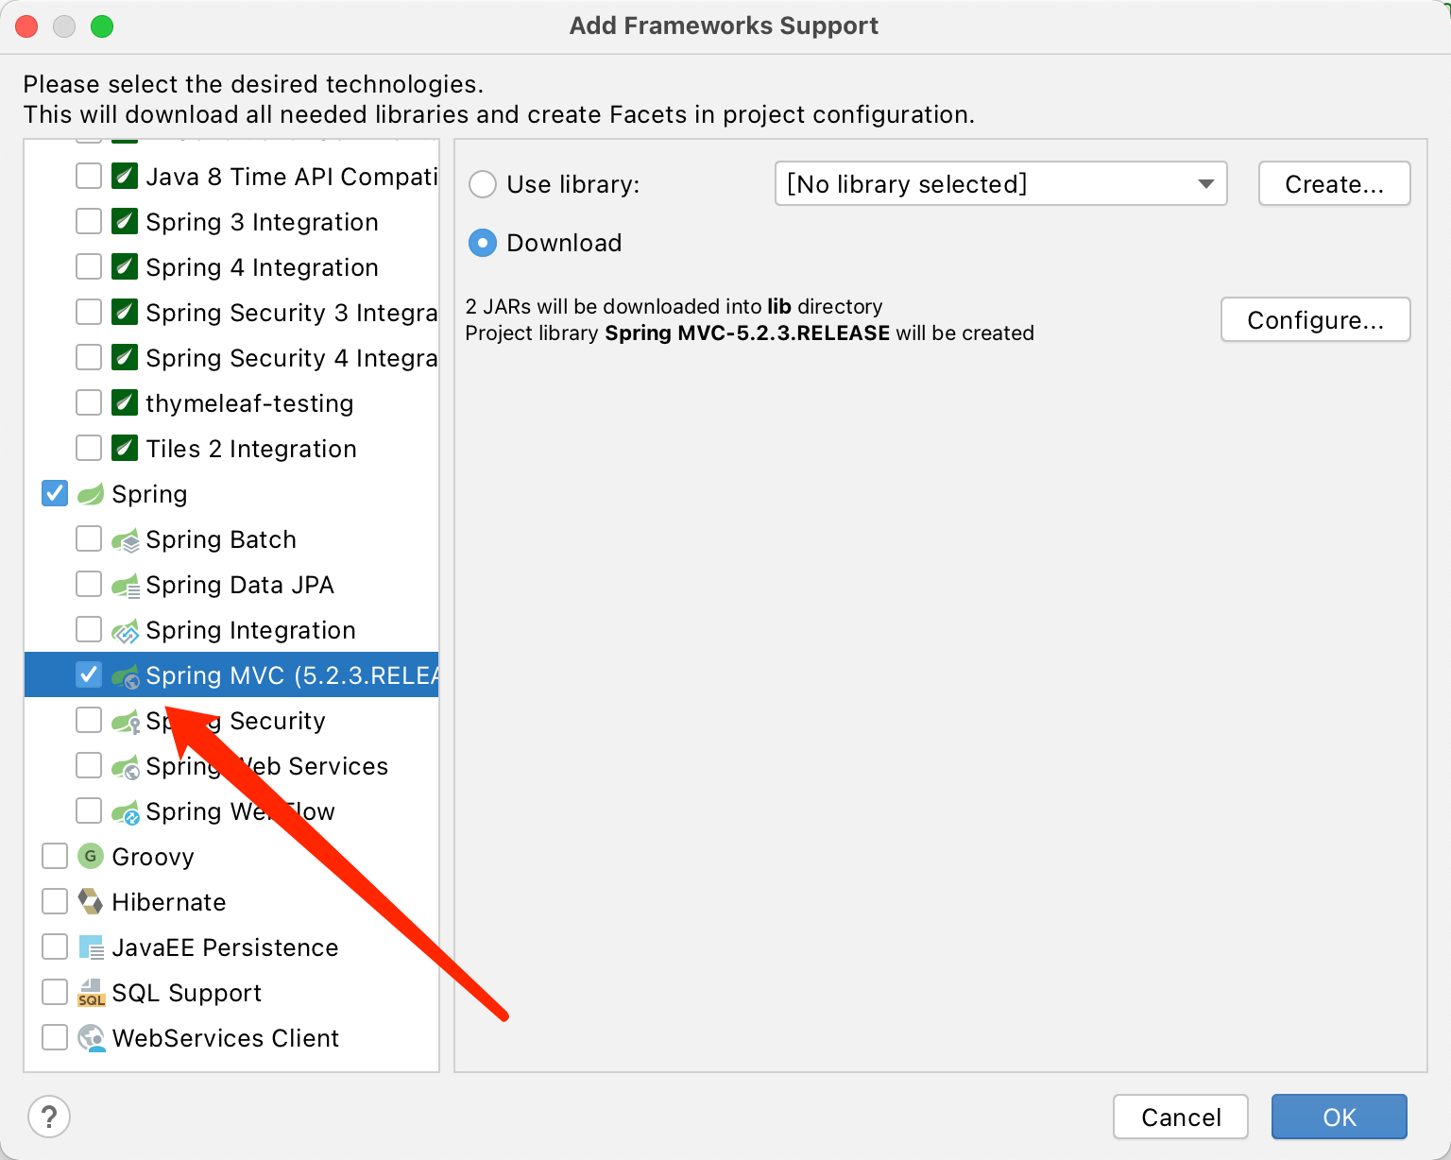
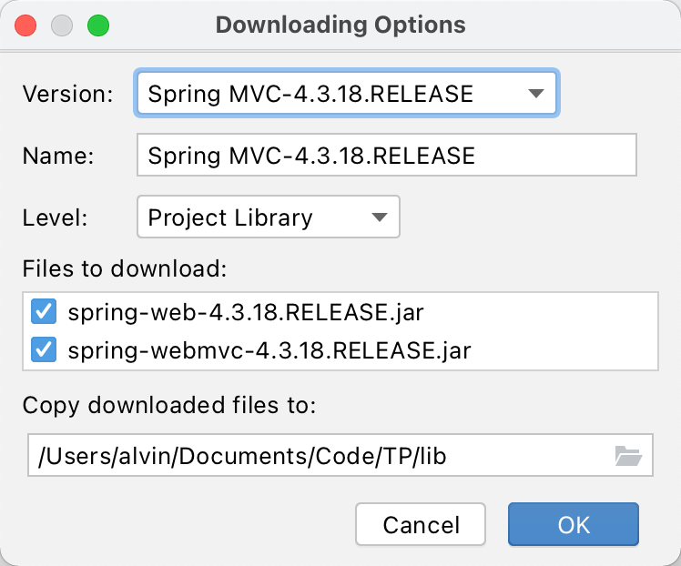
  - 添加classes目录
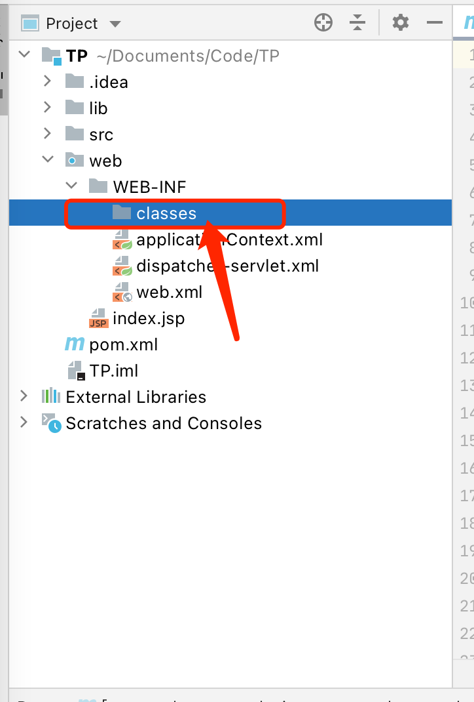
  - 添加javaee依赖
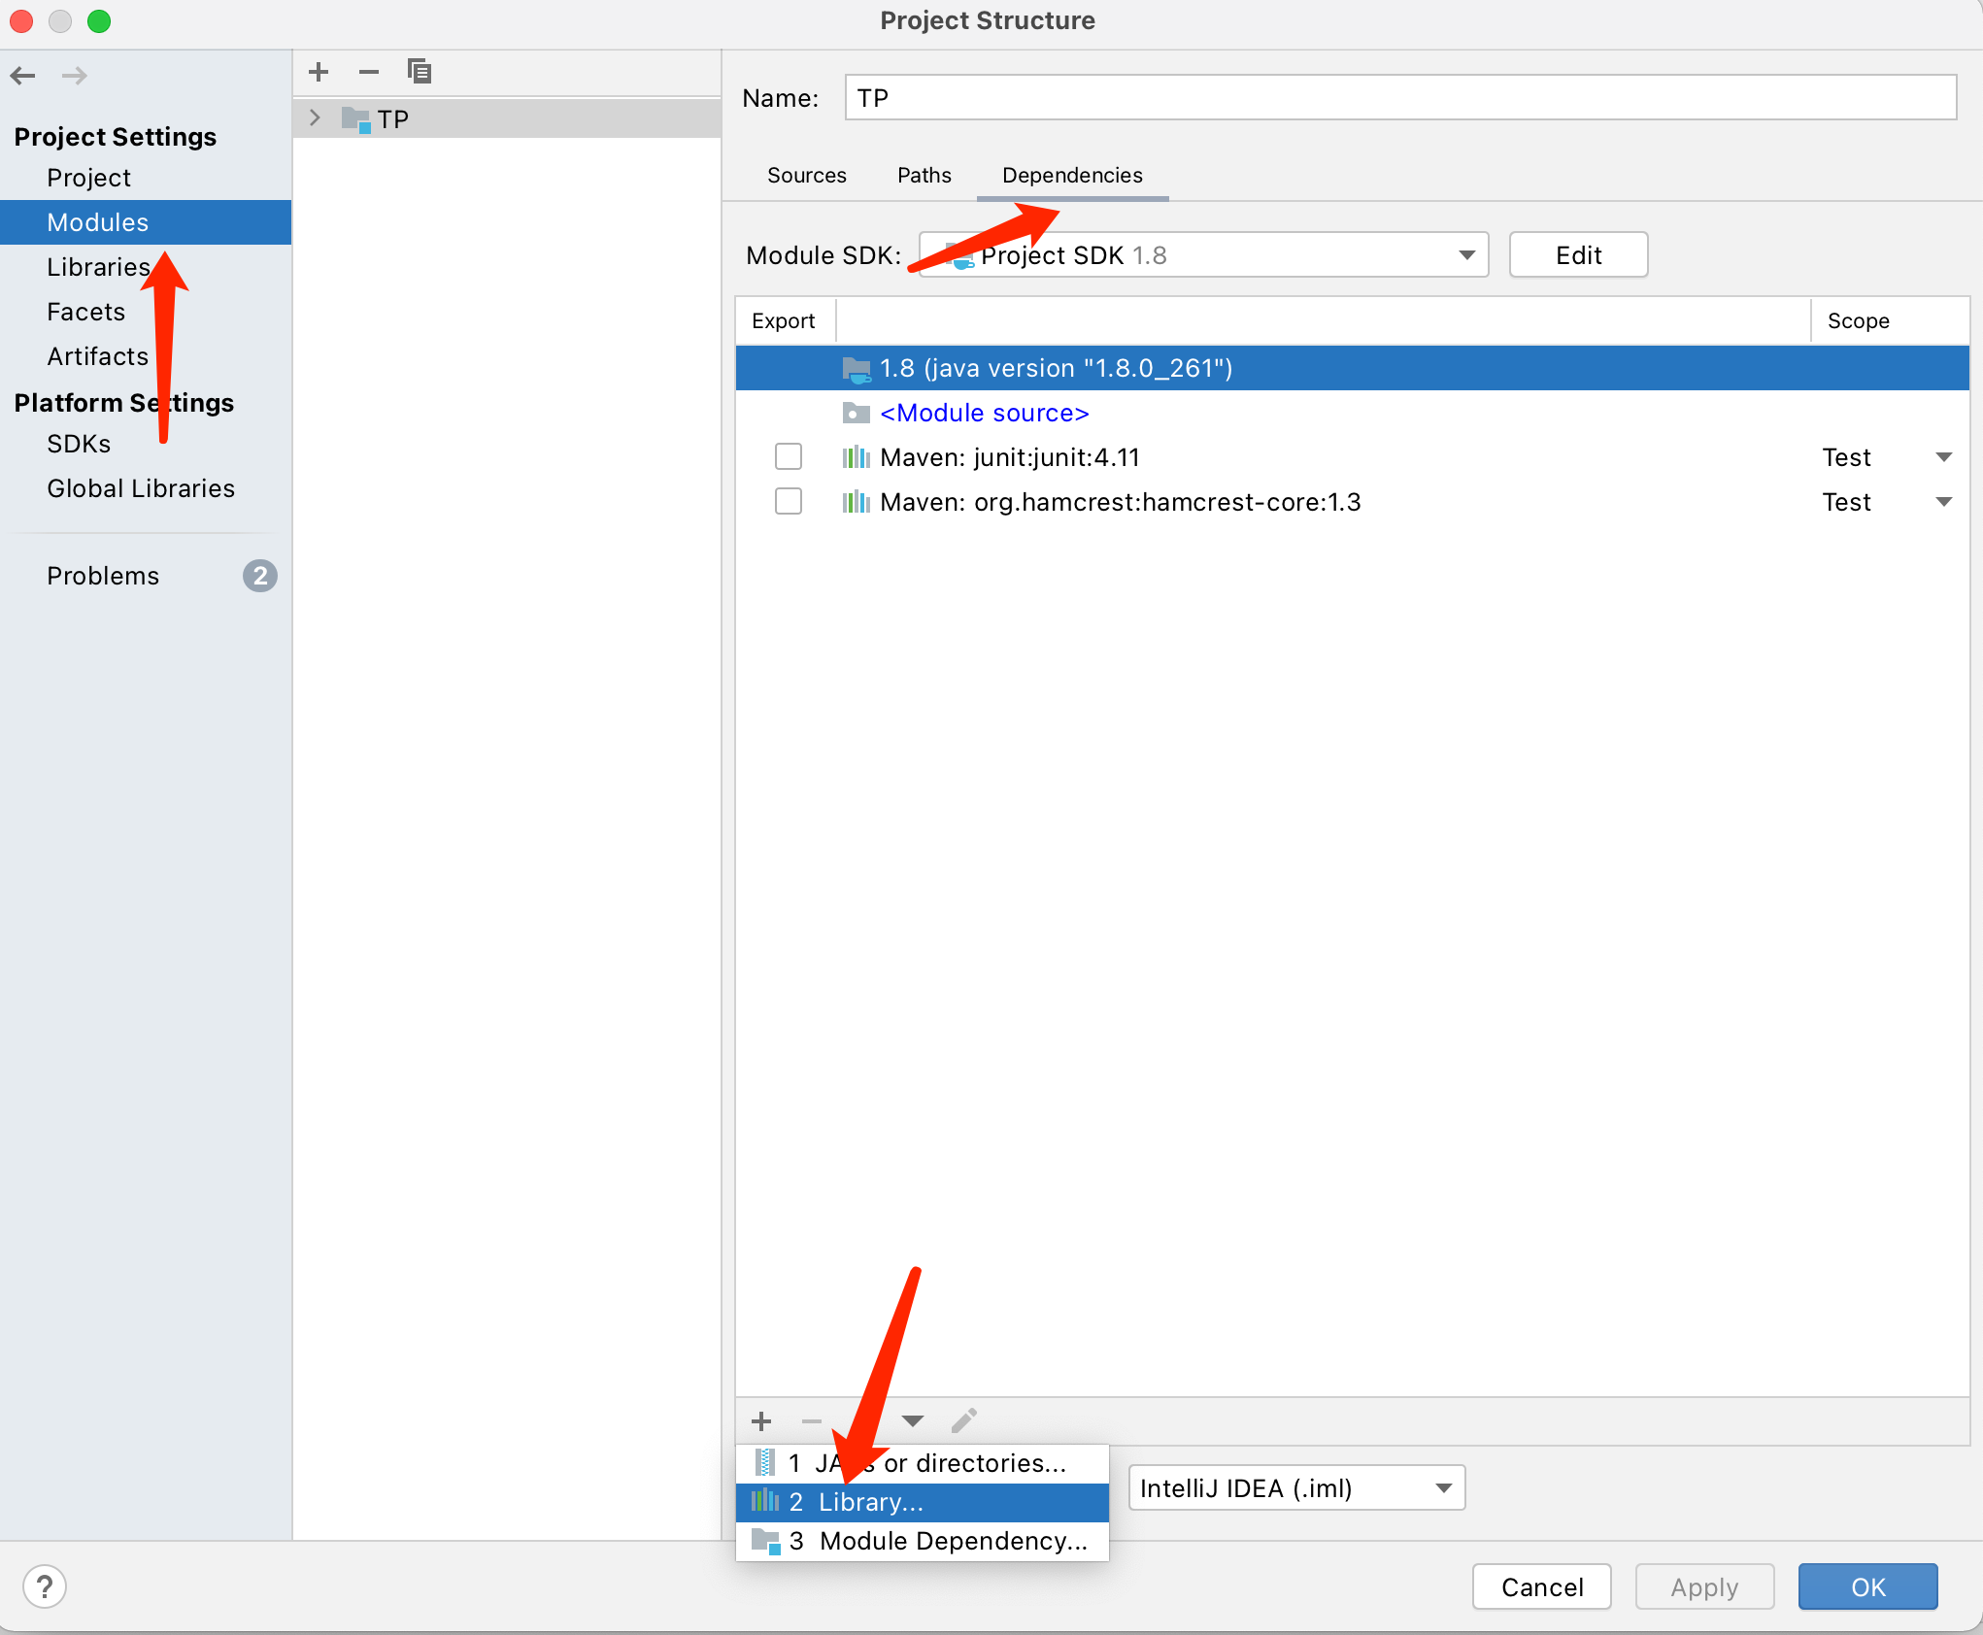
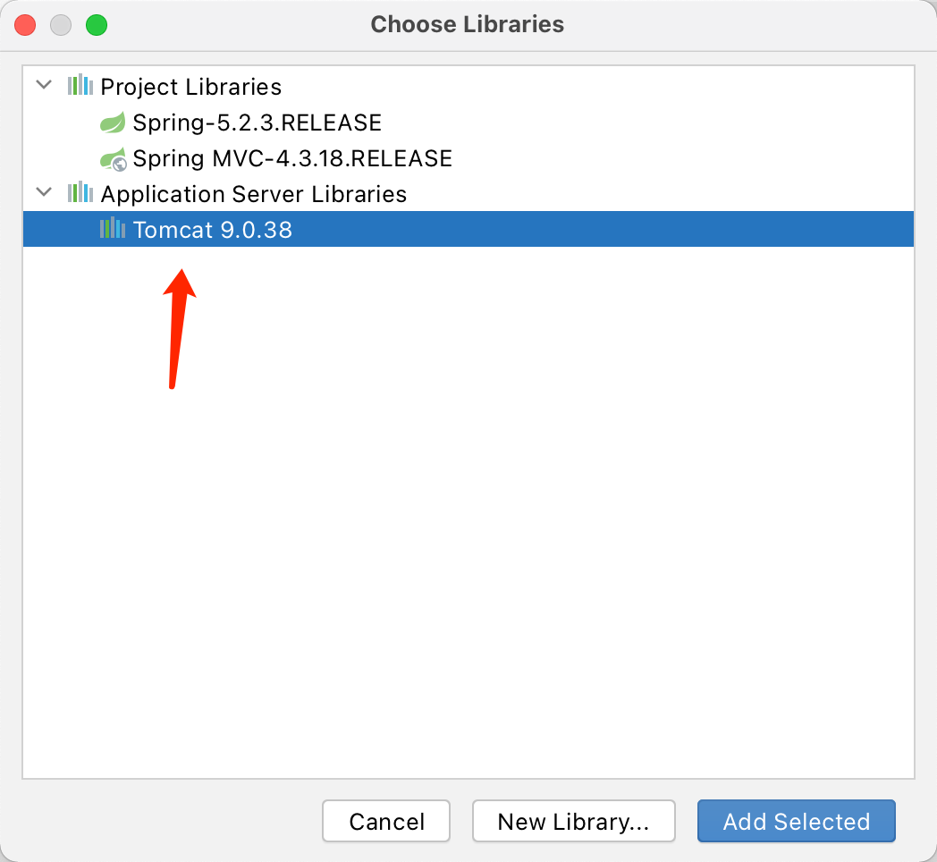
  - 添加lib输出配置
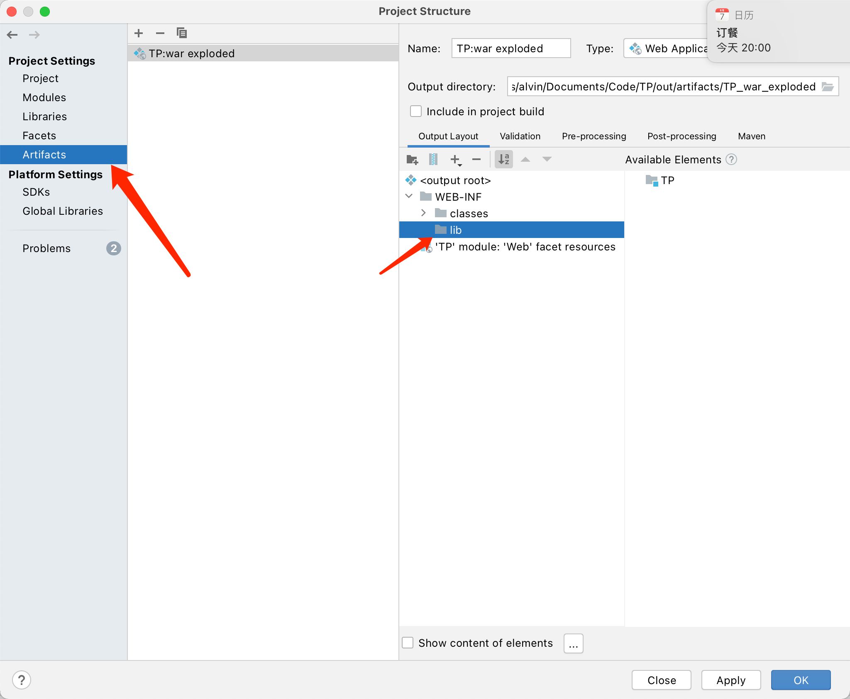
将依赖文件添加至lib中
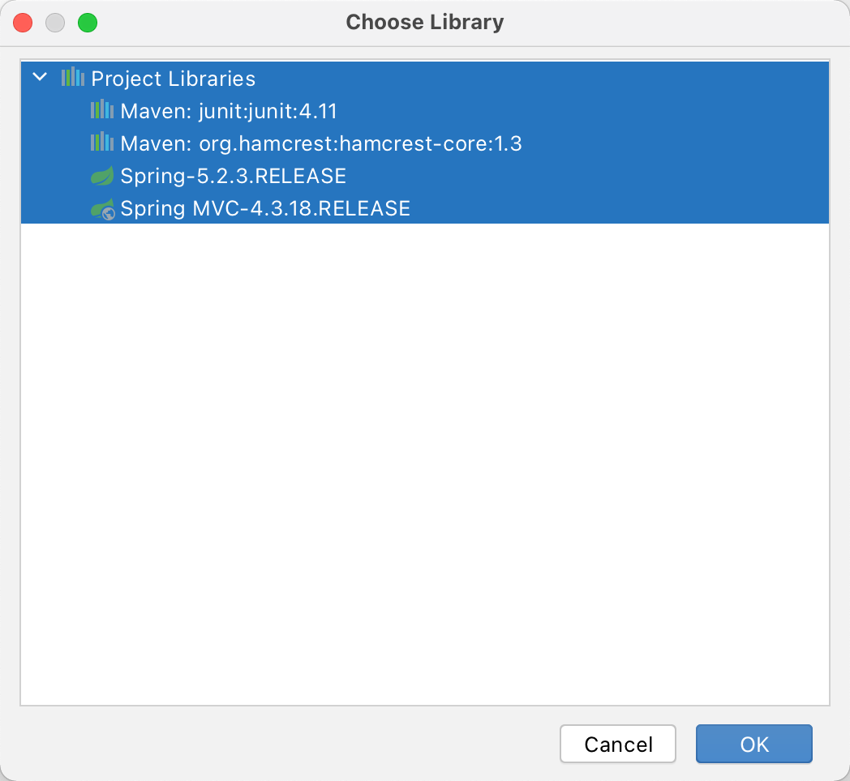
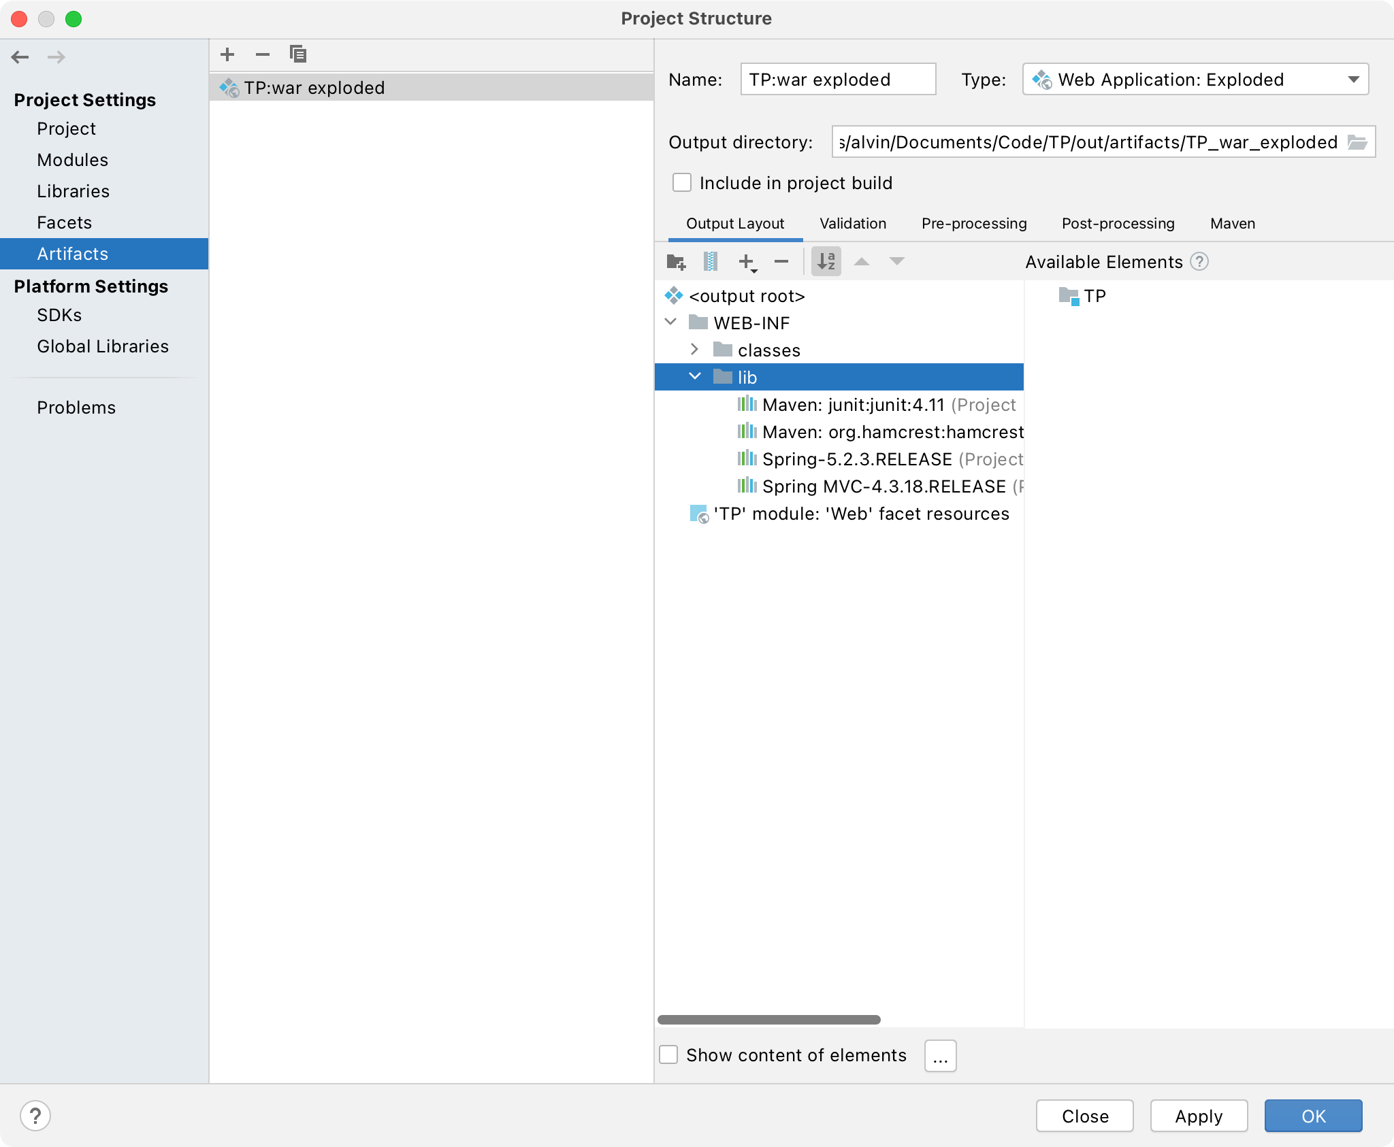
  - 修改web.xml配置
<?xml version="1.0" encoding="UTF-8"?>
<web-app xmlns="http://xmlns.jcp.org/xml/ns/javaee"
xmlns:xsi="http://www.w3.org/2001/XMLSchema-instance"
xsi:schemaLocation="http://xmlns.jcp.org/xml/ns/javaee http://xmlns.jcp.org/xml/ns/javaee/web-app_4_0.xsd"
version="4.0">
<context-param>
<param-name>contextConfigLocation</param-name>
<param-value>/WEB-INF/applicationContext.xml</param-value>
</context-param>
<servlet>
<servlet-name>dispatcher</servlet-name>
<servlet-class>org.springframework.web.servlet.DispatcherServlet</servlet-class>
<init-param>
<param-name>contextConfigLocation</param-name>
<param-value>/WEB-INF/applicationContext.xml</param-value>
</init-param>
<load-on-startup>1</load-on-startup>
</servlet>
<servlet-mapping>
<servlet-name>dispatcher</servlet-name>
<url-pattern>*.form</url-pattern>
</servlet-mapping>
<filter>
<filter-name>charactorEncoding</filter-name>
<filter-class>
org.springframework.web.filter.CharacterEncodingFilter
</filter-class>
<init-param>
<param-name>encoding</param-name>
<param-value>UTF-8</param-value>
</init-param>
</filter>
<filter-mapping>
<filter-name>charactorEncoding</filter-name>
<url-pattern>/*</url-pattern>
</filter-mapping>
</web-app>
  - 修改applicationContext.xml
<?xml version="1.0" encoding="UTF-8"?>
<beans xmlns="http://www.springframework.org/schema/beans"
xmlns:context="http://www.springframework.org/schema/context"
xmlns:aop="http://www.springframework.org/schema/aop"
xmlns:xsi="http://www.w3.org/2001/XMLSchema-instance"
xmlns:tx="http://www.springframework.org/schema/tx"
xmlns:mvc="http://www.springframework.org/schema/mvc"
xsi:schemaLocation="http://www.springframework.org/schema/beans
http://www.springframework.org/schema/beans/spring-beans.xsd
http://www.springframework.org/schema/context
http://www.springframework.org/schema/context/spring-context.xsd
http://www.springframework.org/schema/aop
http://www.springframework.org/schema/aop/spring-aop.xsd
http://www.springframework.org/schema/tx
http://www.springframework.org/schema/tx/spring-tx.xsd
http://www.springframework.org/schema/mvc
http://www.springframework.org/schema/mvc/spring-mvc.xsd">
<mvc:annotation-driven />
<mvc:default-servlet-handler />
<context:annotation-config></context:annotation-config>
<context:component-scan base-package="cs18.controller"/>
</beans>
  - 添加controller，TestController.java
@Controller
public class TestController {
@RequestMapping(value = "/showName")
public String showName(HttpServletRequest request, HttpServletResponse response)
{
//访问传递的参数
;
return "index.jsp";
}
}
  - 配置tomcat，添加项目部署
  - 启动tomcat，在浏览器中输入以下地址
http://localhost:8080/TestSpringMvc/showName?name=fredy
- 测试以下不同类型数据绑定方法
  - HttpServletRequet，HttpSession，Model/ModelMap
  - 简单数据类型绑定（int，String等）
  - POJO数据绑定
  - 包装POJO数据绑定
  - 自定义数据类型绑定
  - 数组或集合绑定
  - 使用Json风格类型的数据绑定

